|  |  |  |  |  |  |
| --- | --- | --- | --- | --- | --- |
|  | **SUKKUR IBA UNIVERSITY**  MERIT – QUALITY – EXCELLENCE | | | |  |
| Lab handout 01 | | | | | |
| Object Oriented Programming (CSE-211), Spring 2021 | | | | | |
| **Name:** Abdul Mateen Khilji | | **CMS ID#:** 033-19-0008 | | **Instructor:** Dr. Abdul Aziz | |
| **Section:** A Lab group: X/Y | | **Department:** Electrical Engineering | | **Marks obtained:** out of 100% | |
| **NOTE: Submit before next lab** | | | **Submitted on 04-02-2021** | | |

|  |  |  |  |  |  |
| --- | --- | --- | --- | --- | --- |
| RUBRIC | | | | | |
| **Criteria** | **Fully meets criteria (80~100 %)** | **Almost meets criteria (60~79%)** | **Progressing to meet criteria (40~59%)** | **Below Expectations (0~39%)** | **Total out of 100%** |
| **Arrival time, attention, discipline, behavior, willingness, participation** | Excellent | Good | Average | Poor | 100% |
| **Understanding of programming, concepts, creativity** | Excellent | Good | Average | poor | 100% |
| **Computer, Java IDE, editor proficiency** | Excellent | Good | Average | poor | 90% |
| **Each program prints your name as a first line** | Excellent | Good | Average | poor | 100% |
| **Equipment handling** | Excellent | Good | Average | poor | 90% |
| **Guidance required** | No | Little | yes | Lot of guidance required | 80% |
| **Helping group/class mates/teacher** | Extremely helpful | Helpful | Don't do or ask for help | Require help | 90% |
| **Coding layout** | Excellent | Good | Average | poor | 90% |
| **Readability of screenshots** | Excellent | Good | Average | poor | 90% |
| **Program results** | Perfect | Acceptable | Minor variations | Different than required | 80% |
| **Methodology** | Planned task extremely well and followed instructions | Planned task well and followed instructions | Planned and followed task instructions roughly | Did not plan well and did not follow instructions fully | 80% |
| **Mentioned program number and title** | Excellent | Good | Average | poor | 70% |
| **Before leaving lab, student placed everything back at proper place, turned off equipment etc.** | Excellent | Good | Average | poor | 100% |
| **Submitted handout on time** | Yes | Less than 1 day late | Less than 3 days late | A week or later | 100% |
| **Followed guidelines to solve and submit handout without cheating** | Excellent | Good | Average | poor | 90% |
| **Minimum score in any of the criteria** | | | | | 70% |

**Downloading, installing & setting up JDK & NetBeans IDE to write, compile, execute and debug Java programs**

**Objectives**

* **Download, install and setup JDK**
* **Download, install and setup NetBeans**
* **Learn to write, compile, execute simple Java programs using notepad**
* **Learn to write, run simple Java programs using NetBeans**
* **Differentiating and debugging programming errors**

**Hardware and software required**

PC with:

* **JDK 15.0.2**
* **NetBeans IDE 12.2**
* **Notepad**
* **Access to internet**
* **Access to LMS**
* **Online Java compilers**

**Theory**

JDK stands for Java development kit and it is a software/tool for programmers who want to write and run java programs. JDK contains Java development tools such as java, javac, Javadoc etc and JRE. Java development tools are used for different purposes such as compiling (generating bytecode for JRE), debugging etc. Command “javac” is used to compile java program. Command “javadoc” is used to generate file for program description. Command “jar” is used to combine multiple classes etc to make it as one package for distribution.

If someone don’t want develop java programs and just run java programs then they need only JRE to interpret bytecode and generate output with the help of JVM and java libraries etc.

JRE which stands for Java Runtime Environment has a purpose to provide environment for java codes to be executed. Since, java byte codes are machine independent therefore there is JVM which stands for Java Virtual Machine and it is the part of JRE. JVM loads bytecode, verifies it and interprets bytecode into machine code for execution. JRE also contains libraries required by JVM for bytecode to be executed. JDK, JRE, JVM all are OS/machine dependent but not the bytecode.

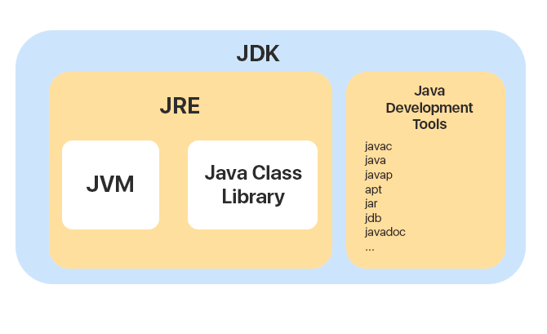

Java program is run in the following steps.



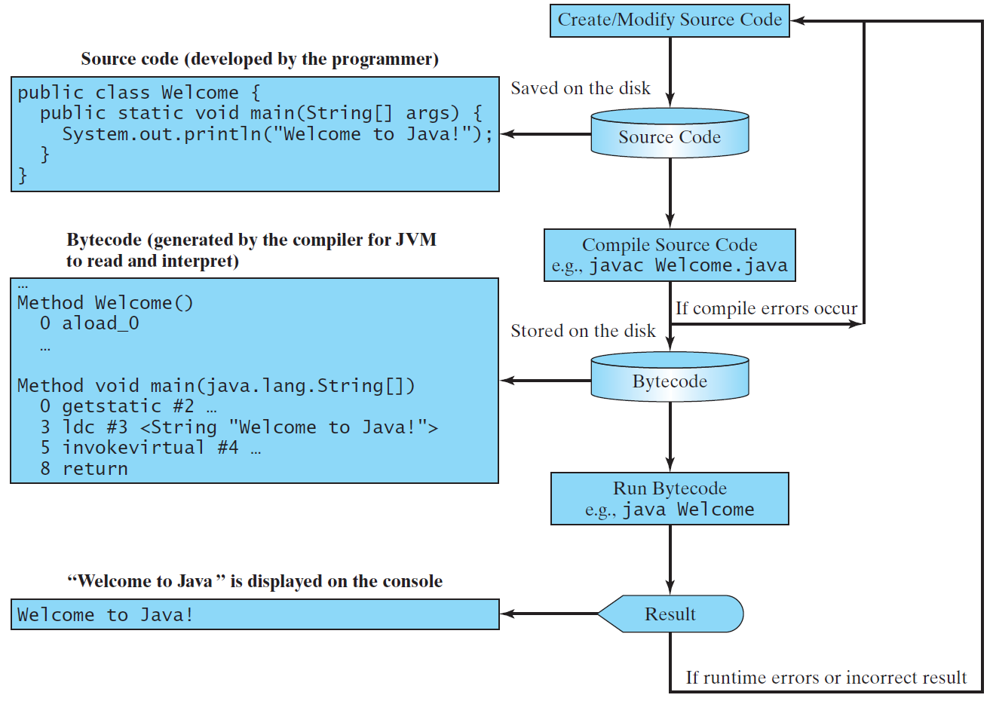

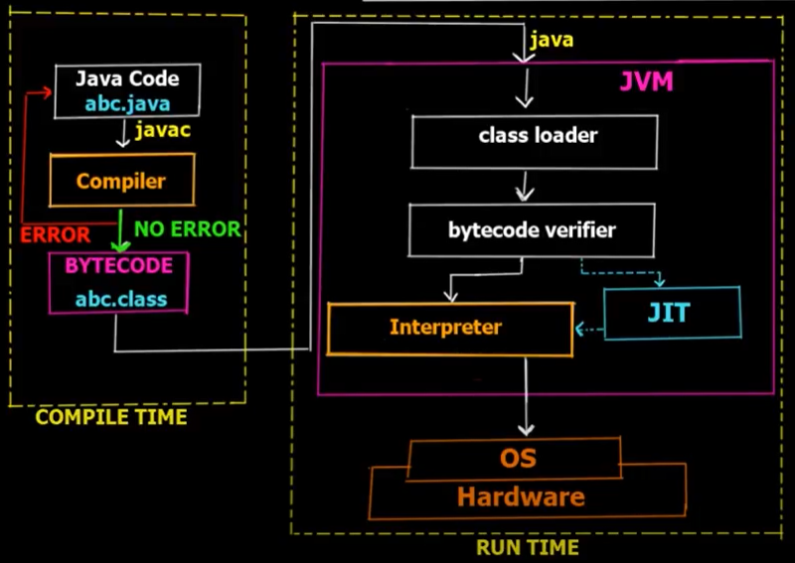

* **Download, install and setup JDK**

Browse <https://www.oracle.com/>

Navigate to products>Software>Java

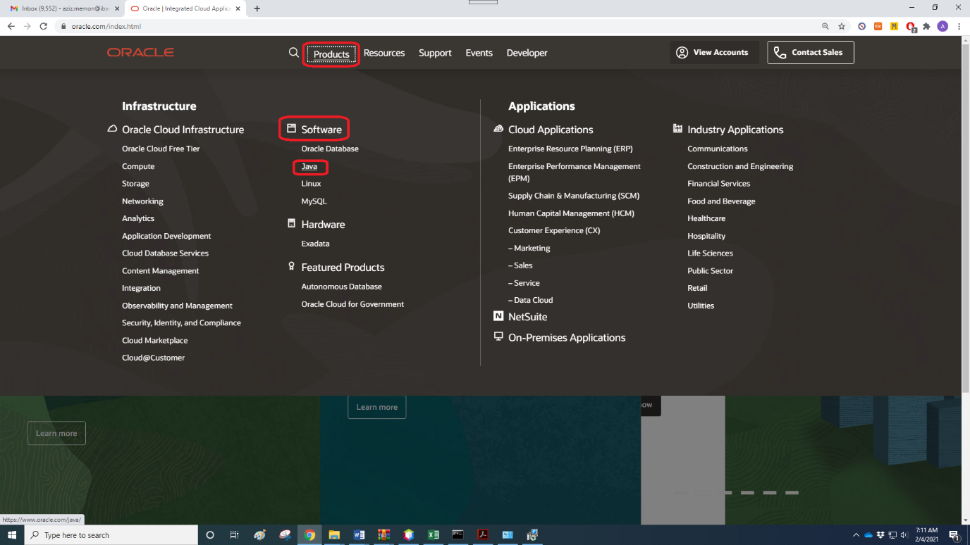

Click on download Java



Click on JDK Download

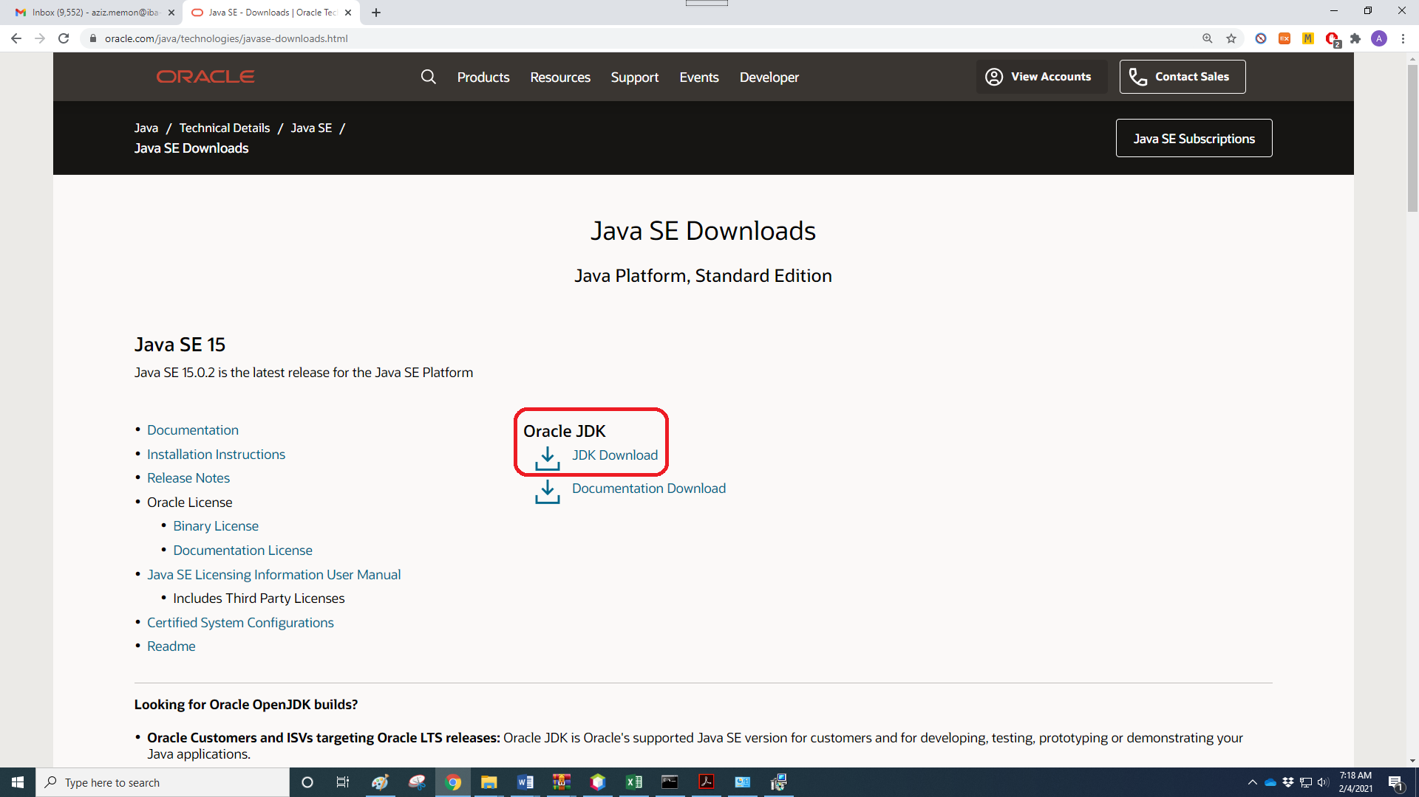

Click on [jdk-15.0.2_windows-x64_bin.exe](https://www.oracle.com/java/technologies/javase-jdk15-downloads.html#license-lightbox)

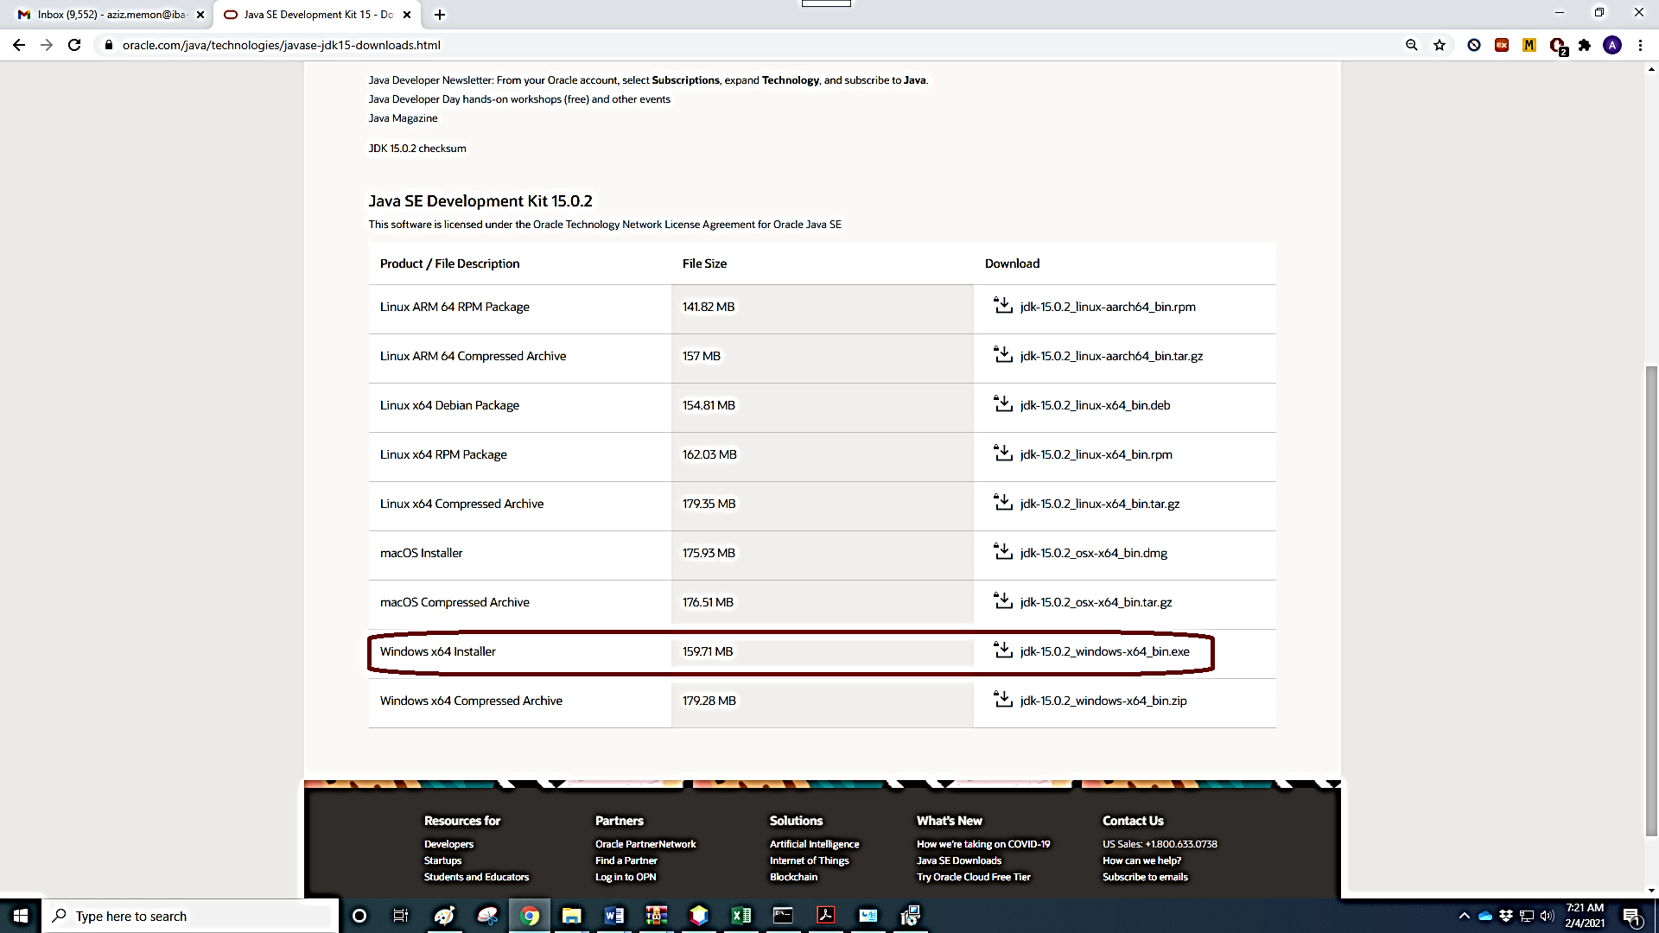

Accept agreement to stat downloading

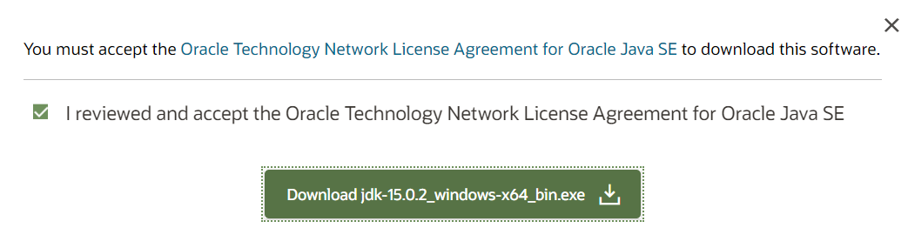

JDK can be directly downloaded by clicking following link.

<https://download.oracle.com/otn-pub/java/jdk/15.0.2%2B7/0d1cfde4252546c6931946de8db48ee2/jdk-15.0.2_windows-x64_bin.exe>

Double click downloaded JDK and click YES to allow JDK to make changes to system and then click NEXT.

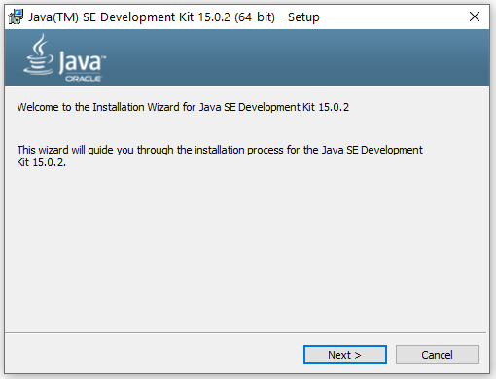

Installation location by default C:\Program Files\Java\jdk-15.0.2\

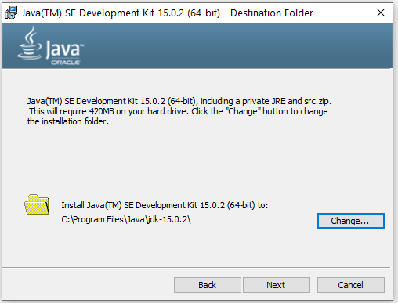

Installation in progress

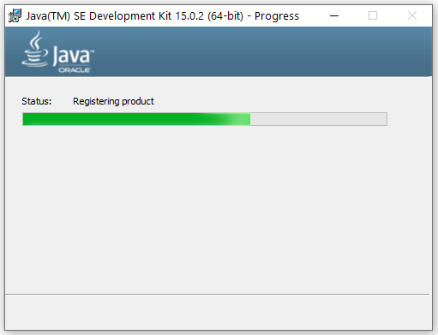

JDK successfully installed, click CLOSE

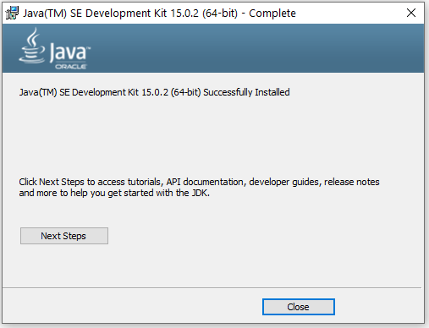

We need to set Java path so that whenever java program will be compiled or executed it can locate JDK easily. Path can be set in two ways i.e. temporarily and permanently.

To set java path temporarily, open command prompt and run command “set path=C:\Program Files\Java\jdk-15.0.2\bin”. Once the command prompt is closed, java path needs to be set again.

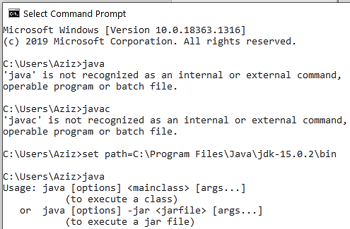

To set java path permanently, this path “C:\Program Files\Java\jdk-15.0.2\bin” should be added as per following steps.

Go to Control Panel > System and Security > System, and then click Advanced system settings to view System properties window. In system properties window press advanced tab and click on Environment variables to add new path. Finally click ok and you are all set.

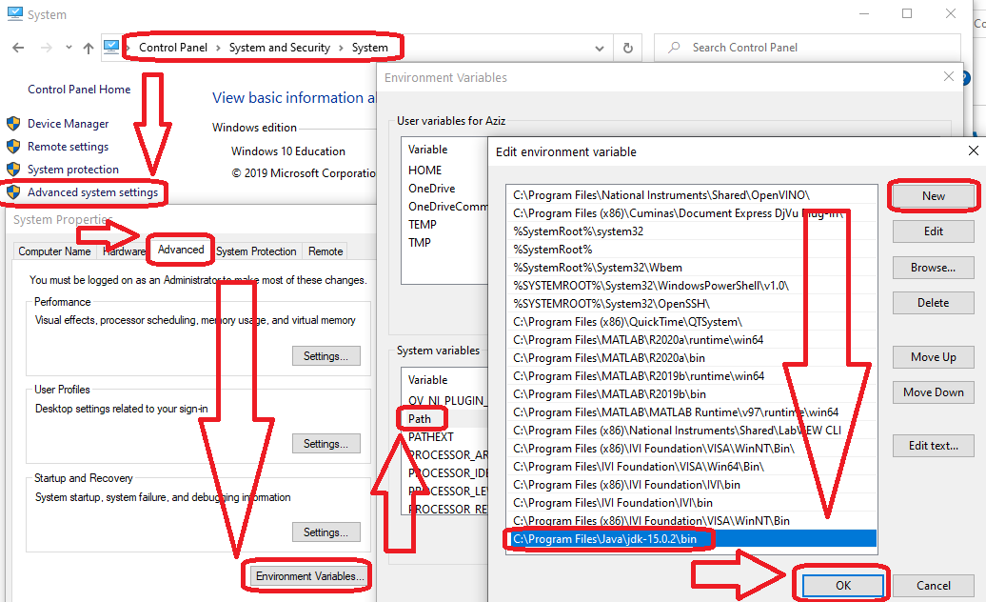

To check if the Java compiler is installed, open command prompt and run command “javac -version”. If the command returns something such as “javac 15.0.2”, it means JDK having Java compiler is installed successfully.

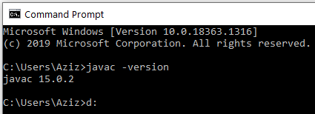

To check version information of JDK, JRE and JVM, open command prompt and run command “java -version”.

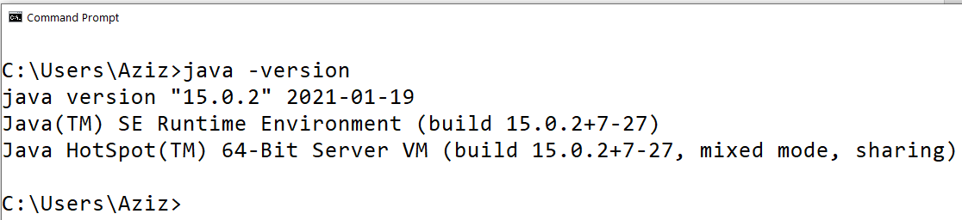

* **Download, install and setup NetBeans**

Go to website <https://netbeans.org/> and click download.

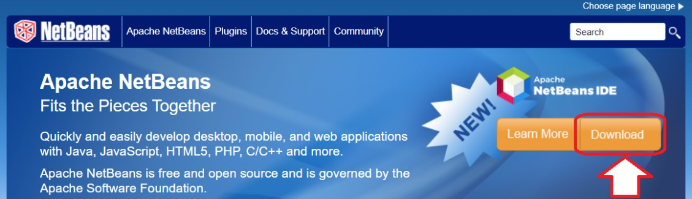

Click to download NetBeans 12.0 LTS (Long term support)

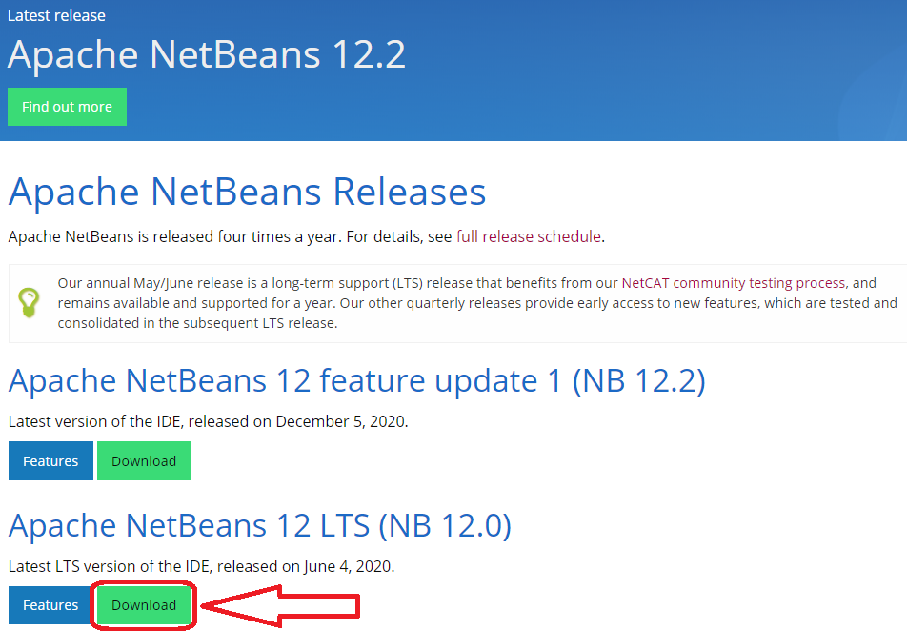

Click to download [Apache-NetBeans-12.0-bin-windows-x64.exe](https://www.apache.org/dyn/closer.cgi/netbeans/netbeans/12.0/Apache-NetBeans-12.0-bin-windows-x64.exe) ([SHA-512](https://downloads.apache.org/netbeans/netbeans/12.0/Apache-NetBeans-12.0-bin-windows-x64.exe.sha512), [PGP ASC](https://downloads.apache.org/netbeans/netbeans/12.0/Apache-NetBeans-12.0-bin-windows-x64.exe.asc))

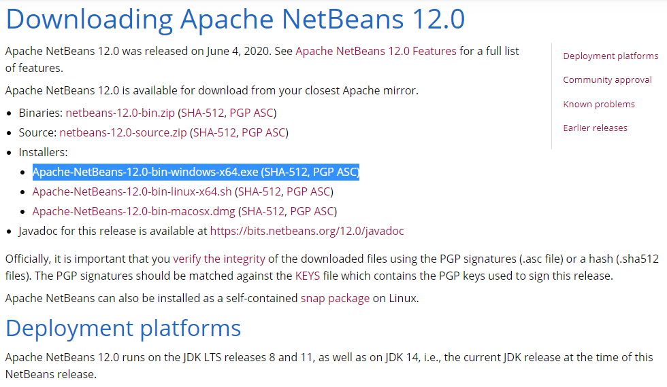

Click to download <https://downloads.apache.org/netbeans/netbeans/12.0/Apache-NetBeans-12.0-bin-windows-x64.exe>

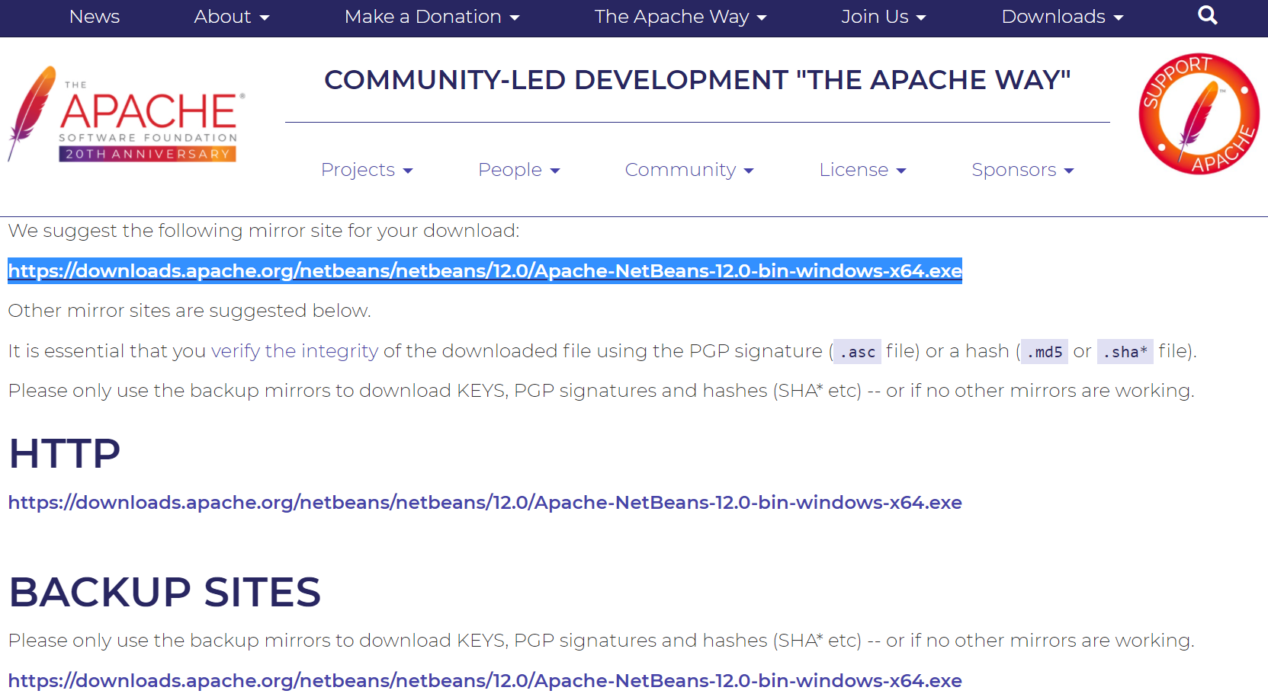

Double click on downloaded Apache-NetBeans-12.0-bin-windows-x64.exe file. Allow this application to make changes to your device.

You may customize, not to install PHP and Java EE. Click next.

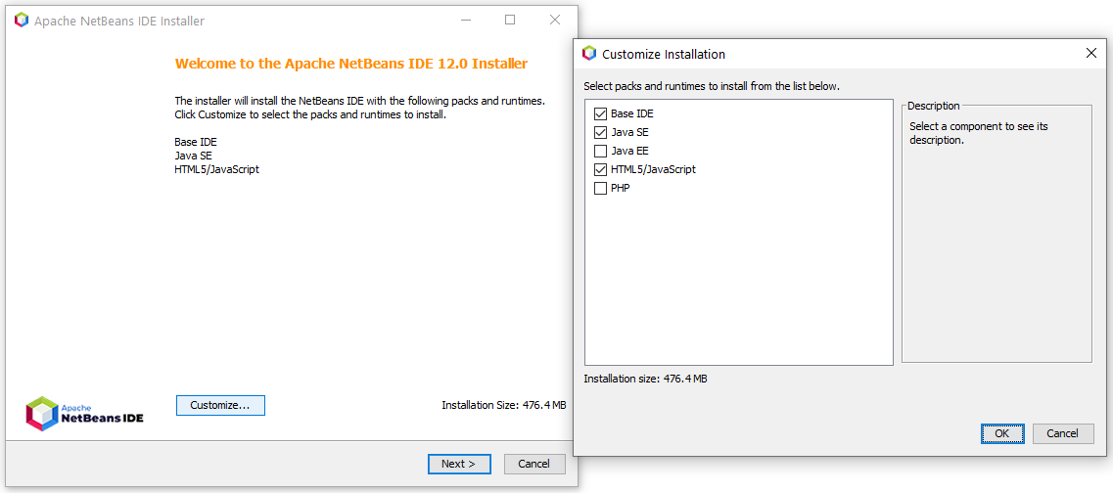

Accept license agreement and click next.

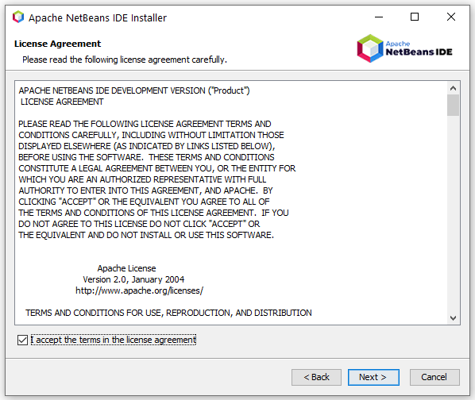

Verify/browse proper JDK location and click next. We have already learnt to install JDK-15.0.2.

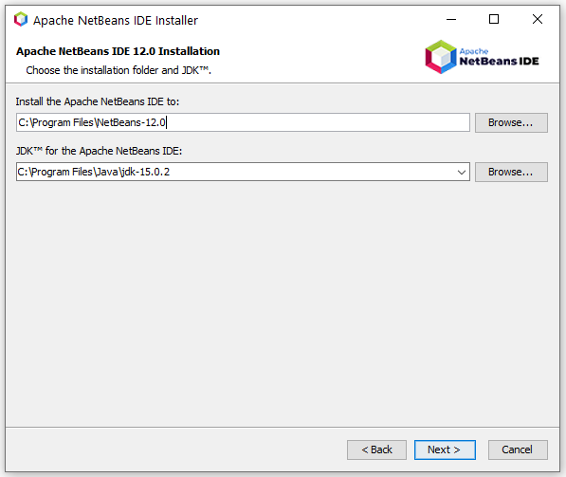

Allow “Check for updates” and click install.

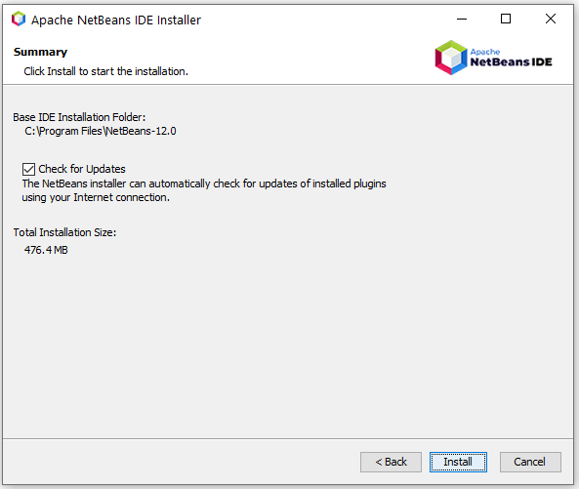

Installation in process.

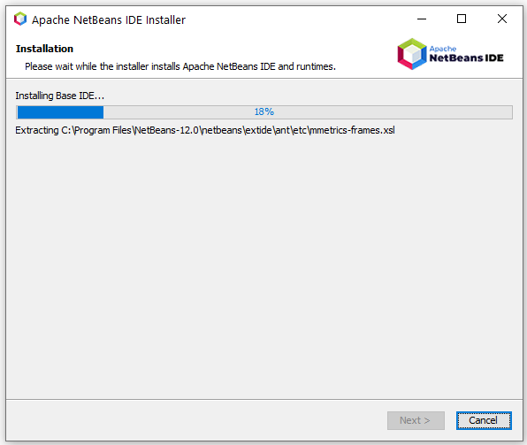

Installation complete, click finish.

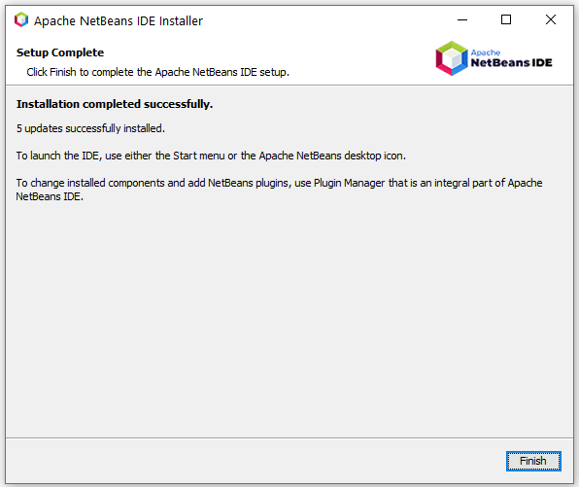

* **Learn to write, compile, execute simple Java programs using notepad**

Open notepad and write following code.

|  |
| --- |
| Program 1.1 |
|  |

In java language, file name should be same as “class” name in which “main” function is called. Further, file extension should be “.java”.

Open command prompt and navigate to location where aziz_1_1.java is stored. (D drive)

Write command javac aziz_1_1.java to compile this program and to obtain bytecode in the same folder with same name and .class extension.

Write command java aziz_1_1 to interpret and execute bytecode to obtain following result.

**Output:**

Dr. Abdul Aziz

Welcome to Java Programming!

* **Learn to write, run simple Java programs using NetBeans**

Output can be seen in another window just below the code file.

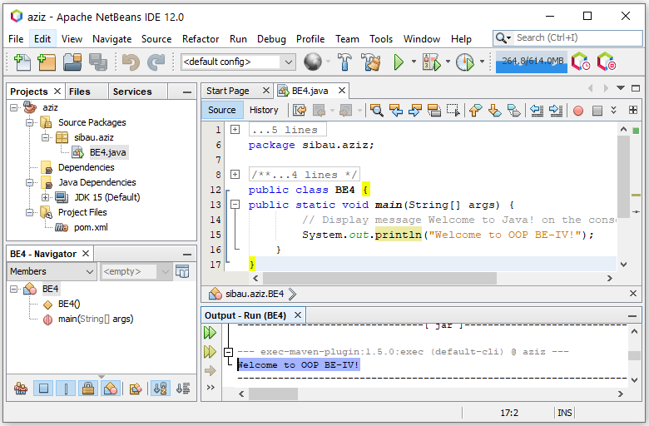

Note: Once the program is run and if it says that no main classes found then right click on class file BE4.java and then click run.

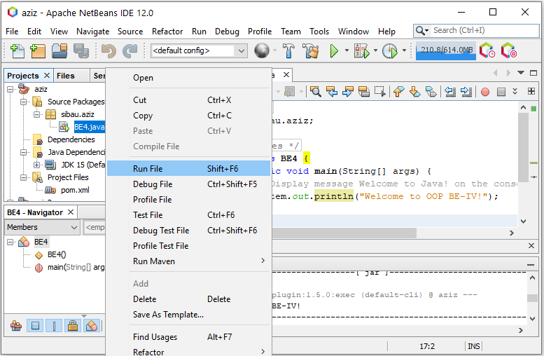

Or set main class by right clicking project aziz from project window on left side>properties>run>Browse main class

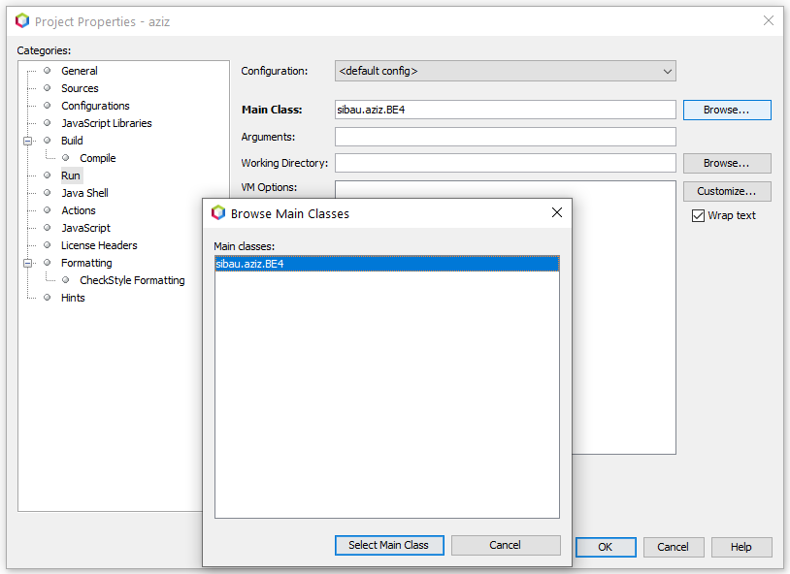

Note: Next time you don’t have to download activate feature. You are ready to create new projects for practice.

Three messages, each on new line.

|  |
| --- |
| Program 1.2 |
| //Code  public class WelcomeWithThreeMessages {  public static void main(String[] args) {  System.out.println("Programming is fun!");  System.out.println("Fundamentals First");  System.out.println("Problem Driven");  }  } |
| Output:  Programming is fun!  Fundamentals First  Problem Driven |

System.out.println🡺used to print some text and moves cursor to new line

System.out.print🡺used to print some text and does not move cursor to new line

Arithmetic operations🡺 println with double quotation prints whatever as it is. Without double quotation it can be used to compute expression. Without double quotation println or print can’t solve characters or strings.

|  |
| --- |
| Program 1.3 |
| //Code  public class ComputeExpression {  public static void main(String[] args) {  System.out.print("(10.5 + 2 * 3) / (45 - 3.5) = ");  System.out.println((10.5 + 2 * 3) / (45 - 3.5));  }  } |
| Output:  (10.5 + 2 * 3) / (45 – 3.5) = 0.39759036144578314 |

Syntax errors: Errors that are detected by the compiler are called *syntax errors* or *compile errors*. Syntax errors result from errors in code construction, such as mistyping a keyword, omitting some necessary punctuation, or using an opening brace without a corresponding closing brace. These errors are usually easy to detect because the compiler tells you where they are and what caused them.

|  |
| --- |
| Program 1.4 |
| public class ShowSyntaxErrors {  public static main(String[] args) {  System.out.println("Welcome to Java);  }  } |
| Output: |

Four errors are reported, but the program actually has two errors:

■ The keyword **void** is missing before **main** in line 2.

■ The string **Welcome to Java** should be closed with a closing quotation mark in line 3.

Since a single error will often display many lines of compile errors, it is a good practice to fix errors from the top line and work downward. Fixing errors that occur earlier in the program may also fix additional errors that occur later.

Runtime errors: *Runtime errors* are errors that cause a program to terminate abnormally. They occur while a program is running if the environment detects an operation that is impossible to carry out. Input mistakes typically cause runtime errors. An *input error* occurs when the program is waiting for the user to enter a value, but the user enters a value that the program cannot handle. For instance, if the program expects to read in a number, but instead the user enters a string, this causes data-type errors to occur in the program.

|  |
| --- |
| Program 1.5 |
| //Code  public class ShowRuntimeErrors {  public static void main(String[] args) {  System.out.println(1 / 0);  }  } |
| Output: |

Logic Errors: *Logic errors* occur when a program does not perform the way it was intended to. Errors of this kind occur for many different reasons. For example, suppose you wrote the program 1.6 to convert Celsius **35** degrees to a Fahrenheit degree. You will get Fahrenheit **67** degrees, which is wrong. It should be **95.0**. In Java, the division for integers is the quotient—the fractional part is truncated—so in Java **9 / 5** is **1**. To get the correct result, you need to use **9.0 / 5**, which results in **1.8**.

In general, syntax and runtime errors are easy to find and easy to correct because those errors can be seen on console. On the other hand, logic errors are difficult to find. We will learn techniques to trace logic errors as well.

|  |
| --- |
| Program 1.6 |
| //Code  public class ShowLogicErrors {  public static void main(String[] args) {  System.out.println("Celsius 35 is Fahrenheit degree ");  System.out.println((9 / 5) * 35 + 32);  }  } |
| Output:  Celsius 35 is Fahrenheit degree 67 |

Common errors are missing braces, semicolons, quotation marks and misspelling java keywords etc.

Declaring variables, assigning value to variables, defining formula, use of println with +

|  |
| --- |
| Program 1.7 |
| //Code ( + 🡺 string concatenation)  public class ComputeArea {  public static void main(String[] args) {  double radius; // Declare radius  double area; // Declare area  // Assign a radius  radius = 20; // New value is radius  // Compute area  area = radius * radius * 3.14159;  // Display results  System.out.println("The area for the circle of radius " +  radius + " is " + area);  }  } |
| Output: |

Using console input with the help of Scanner class to get one value

|  |
| --- |
| Program 1.8 |
| //Code  import java.util.Scanner; // Scanner is in the java.util package  public class ComputeAreaWithConsoleInput {  public static void main(String[] args) {  // Create a Scanner object  Scanner input = new Scanner(System.in);    // Prompt the user to enter a radius  System.out.print("Enter a number for radius: ");  double radius = input.nextDouble();  // Compute area  double area = radius * radius * 3.14159;  // Display result  System.out.println("The area for the circle of radius " +  radius + " is " + area);  }  } |
| Output: |

Using console input with the help of Scanner class to get three values

|  |
| --- |
| Program 1.9 |
| //Code  import java.util.Scanner; // Scanner is in the java.util package  public class ComputeAverage {  public static void main(String[] args) {  // Create a Scanner object  Scanner input = new Scanner(System.in);    // Prompt the user to enter three numbers  System.out.print("Enter three numbers: ");  double number1 = input.nextDouble();  double number2 = input.nextDouble();  double number3 = input.nextDouble();  // Compute average  double average = (number1 + number2 + number3) / 3;  // Display result  System.out.println("The average of " + number1 + " " + number2  + " " + number3 + " is " + average);  }  } |
| Output: |

Constant

|  |
| --- |
| Program 1.10 |
| //Code  import java.util.Scanner; // Scanner is in the java.util package  public class ComputeAreaWithConstant {  public static void main(String[] args) {  final double PI = 3.14159; // Declare a constant    // Create a Scanner object  Scanner input = new Scanner(System.in);    // Prompt the user to enter a radius  System.out.print("Enter a number for radius: ");  double radius = input.nextDouble();  // Compute area  double area = radius * radius * PI;  // Display result  System.out.println("The area for the circle of radius " +  radius + " is " + area);  }  } |
| Output: |

|  |
| --- |
| Program 1.11 |
| //Convert seconds to minutes & seconds  import java.util.Scanner;  public class DisplayTime {  public static void main(String[] args) {  Scanner input = new Scanner(System.in);  // Prompt the user for input  System.out.print("Enter an integer for seconds: ");  int seconds = input.nextInt();    int minutes = seconds / 60; // Find minutes in seconds  int remainingSeconds = seconds % 60; // Seconds remaining  System.out.println(seconds + " seconds is " + minutes +  " minutes and " + remainingSeconds + " seconds");  }} |
| Output: |

|  |
| --- |
| Program 1.12 |
| //Code  import java.util.Scanner;  public class FahrenheitToCelsius {  public static void main(String[] args) {  Scanner input = new Scanner(System.in);  System.out.print("Enter a degree in Fahrenheit: ");  double fahrenheit = input.nextDouble();  // Convert Fahrenheit to Celsius  double celsius = (5.0 / 9) * (fahrenheit - 32);  System.out.println("Fahrenheit " + fahrenheit + " is " +  celsius + " in Celsius");  }  } |
| Output: |

|  |
| --- |
| Program 1.13 |
| //Code  public class ShowCurrentTime {  public static void main(String[] args) {  // Obtain the total milliseconds since midnight, Jan 1, 1970 (Unix Epoch)  long totalMilliseconds = System.currentTimeMillis();  // Obtain the total seconds since midnight, Jan 1, 1970  long totalSeconds = totalMilliseconds / 1000;  // Compute the current second in the minute in the hour  long currentSecond = totalSeconds % 60;  // Obtain the total minutes  long totalMinutes = totalSeconds / 60;  // Compute the current minute in the hour  long currentMinute = totalMinutes % 60;  // Obtain the total hours  long totalHours = totalMinutes / 60;  // Compute the current hour  long currentHour = totalHours % 24;  // Display results  System.out.println("Current time is " + currentHour + ":"  + currentMinute + ":" + currentSecond + " GMT");  }  } |
| Output depends upon current GMT time, PST is GMT+5 hours:  Current time is 17:31:8 GMT |

|  |
| --- |
| Program 1.14 |
| //Code (type casting🡺 from double to int)  import java.util.Scanner;  public class SalesTax {  public static void main(String[] args) {  Scanner input = new Scanner(System.in);  System.out.print("Enter purchase amount: ");  double purchaseAmount = input.nextDouble();    double tax = purchaseAmount * 0.06;  System.out.println("Sales tax is " + (int)(tax * 100) / 100.0);  }  } |
| Output: Tax amount is truncated to 2 decimal places with the help of (int). |

|  |
| --- |
| Program 1.15 |
| //Code  import java.util.Scanner;  public class ComputeChange {  public static void main(String[] args) {  // Create a Scanner  Scanner input = new Scanner(System.in);  // Receive the amount  System.out.print(  "Enter an amount in double, for example 11.56: ");  double amount = input.nextDouble();  int remainingAmount = (int)(amount * 100);  // Find the number of one dollars  int numberOfOneDollars = remainingAmount / 100;  remainingAmount = remainingAmount % 100;  // Find the number of quarters in the remaining amount  int numberOfQuarters = remainingAmount / 25;  remainingAmount = remainingAmount % 25;  // Find the number of dimes in the remaining amount  int numberOfDimes = remainingAmount / 10;  remainingAmount = remainingAmount % 10;  // Find the number of nickels in the remaining amount  int numberOfNickels = remainingAmount / 5;  remainingAmount = remainingAmount % 5;  // Find the number of pennies in the remaining amount  int numberOfPennies = remainingAmount;  // Display results  System.out.println("Your amount " + amount + " consists of");  System.out.println(" " + numberOfOneDollars + " dollars");  System.out.println(" " + numberOfQuarters + " quarters ");  System.out.println(" " + numberOfDimes + " dimes");  System.out.println(" " + numberOfNickels + " nickels");  System.out.println(" " + numberOfPennies + " pennies");  }  } |
| Output: |

* javac means java compiler.
* filename.class is java bytecode file.
* If program compiles correctly then there will be no output or error messages on command line, yet there can be runtime errors later.
* [//]🡺 single line comment
* [/* comments here */]🡺 multiline comment
* System.out.println("a" + 1 + 1)🡺a11, but System.out.println("a" + (1 + 1))🡺 a2, and System.out.println(1 + 1)🡺 2 as well.
* public static void main(String[] args) is same as public static void main(String args[])
* Every line that does not begin a new block of code {new block of code}, terminates with semicolon (;).

**Lab exercise**

* Describe in detail with screenshots that how NetBeans debugger works for Java programs
* Write and run all programs from (program 1.1 to program 1.15) either using textpad + command prompt or NetBeans IDE and then paste codes and screenshots of results at the end of this handout in the lab submission section.
* What will be the result of [System.out.println("Welcome\nto\nJava\nProgramming!");]
* What will be the result of [System.out.println("\"in quotes\"");]

1. Modify program [1.15] ComputeChange.java to compute number of lacs, thousands, hundreds, tens, and paisas.
2. (2.6. *Sum the digits in an integer*) Write a program that reads an integer between **0** and **1000** and adds all the digits in the integer. For example, if an integer is **932**, the sum of all its digits is **14**. *Hint*: Use the **%** operator to extract digits, and use the **/** operator to remove the extracted digit. For instance, **932 % 10 = 2** and **932 / 10 = 93**.
3. (2.8. *Current time*) ShowCurrentTime.java, gives a program that displays the current time in GMT. Revise the program so it prompts the user to enter the time zone offset to GMT and displays the time in the specified time zone. Here is a sample run:
4. (2.14. *Health application: computing BMI*) Body Mass Index (BMI) is a measure of health on weight. It can be calculated by taking your weight in kilograms and dividing, by the square of your height in meters. Write a program that prompts the user to enter a weight in pounds and height in inches and displays the BMI. Note one pound is **0.45359237** kilograms and one inch is **0.0254** meters.
5. (2.15. *Geometry: distance of two points*) Write a program that prompts the user to enter two points **(x1, y1)** and **(x2, y2)** and displays their distance. Note you can use **Math.pow(a, 0.5)** to compute square root.
6. (2.18. *Print a table*) Write a program that displays table of integer “n” in the standard table format as given below. “n” is equal to last two digits of your CMS ID.

1 x n = n

2 x n = 2n

.

.

10 x n = 2n

1. (2.23. *Cost of driving*) Write a program that prompts the user to enter the distance (in miles) to drive, the fuel efficiency of the car in miles per gallon, and the price per gallon then displays the cost of the trip.

* Verify that:
* From command prompt: command [notepad] and [write] are used to open NotePad and WordPad respectively.
* [notepad filename.java] can be used to directly open program in NotePad using command window.
* If such file does not exist then you will be prompted to create notepad file with name filename.java
* A program written in notepad can be opened in Wordpad using [write filename.java] command in command prompt.
* [type filename.java] opens file contents in command prompt.
* What is the use of [set classpath=class_path_here]? i.e. set classpath=c:\code\aziz\
* How can we run Java programs using command prompt and without navigating to actual directory where [filename.java] is stored?

How to change directory in command window:

* Just write cd+complete path and press enter (cd d:\javaprograms\handout1)
* Just write drive letter (d:\) and press enter
* You will in specific directory (d:\javaprograms\handout1)

Online Java IDEs (class name should be changed to “Main” for first two links and MyClass for third link)

<https://www.onlinegdb.com/online_java_compiler>

<https://repl.it/languages/java10>

<https://www.jdoodle.com/online-java-compiler/>

**Lab submission**

* Describe in detail with screenshots that how NetBeans debugger works for Java programs

Using the NetBeans Debugger for the program 1.11:

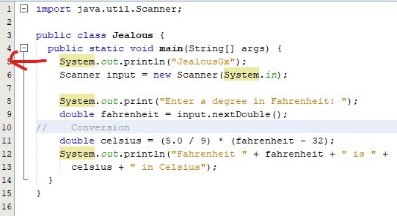

In this program, we have set up the break point by clicking at left side of the line number 5. In this way, we will be able to tell the debugger from where to start debugging.

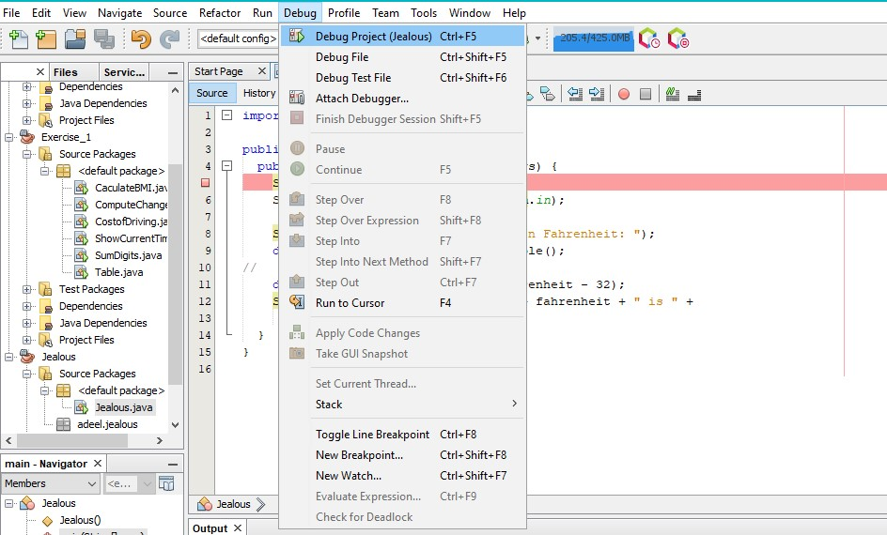

In the above picture, the red rectangular can be seen at the line number 5. Right after that, we will look for “Debug” button in the menu-bar and that will display the shown list, from where, we will select “Debug Project (ClassName) (In my case, it’s Jealous)”.

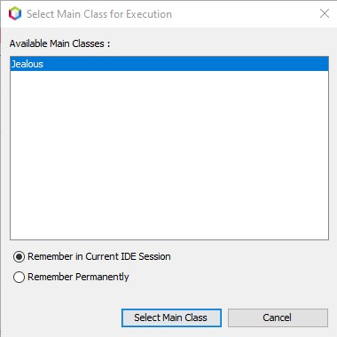

After clicking the button, this dialog will appear before you in which, you will have to select the selected option and then continue to “Select Main Class”.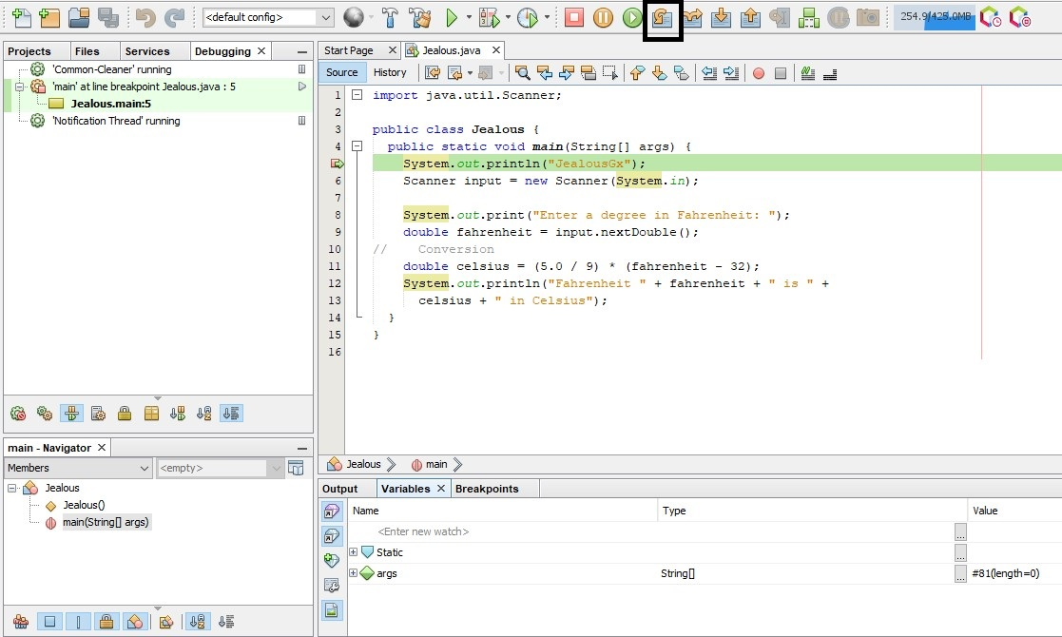

Right after that, the process of debugging will appear in your IDE. Through which, we will be able to debug our program. It can be seen from the above attached picture that we can select “Step Over” icon to continue onto the next line. We will continue to the next lines until we are asked for the input (It can be seen in the bottom status bar -> Output).

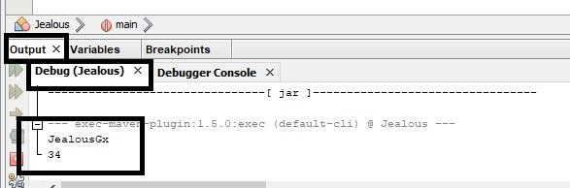

The above picture shows the input that we have given the number “34” to execute the program. We will move unto next lines using “Step Over” option to continue to the next lines.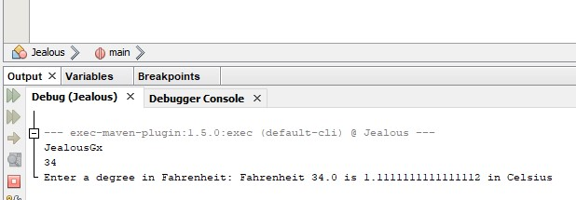

The output can be seen in the last line.

And in the end, we will get to see that the build was successful. 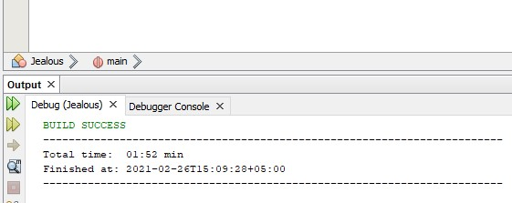

* Write and run all programs from (program 1.1 to program 1.15) either using textpad + command prompt or NetBeans IDE and then paste codes and screenshots of results at the end of this handout in the lab submission section.

|  |
| --- |
| Program 1.1: |
| public class BE4 {  public static void main(String[] args) {  /////Simple welcome Java Program  System.out.println("---------------------");  System.out.println("Author: JealousGx");  System.out.println("Welcome to OOP BE-IIII");  System.out.println("---------------------");  }  } |
| Output: |

|  |
| --- |
| Program 1.2: |
| public class WelcomeWithThreeMessages {  public static void main(String[] args) {  /////Simple multi line Java program  System.out.println("---------------------");  System.out.println("Author: JealousGx");  System.out.println("*********************");  System.out.println("Programming is fun!");  System.out.println("Fundamentals first");  System.out.println("Problem driven");  System.out.println("---------------------");  }  } |
| Output: |

|  |
| --- |
| Program 1.3: |
| public class ComputeExpression {  public static void main(String[] args) {  /////Simple mathematical operation in Java  System.out.println("---------------------");  System.out.println("Author: JealousGx");  System.out.println("*********************");  System.out.print("(10.5 + 2 * 3)/(45 - 3.5) = ");  /////System.out.print won't break the like instead, it will continue on the same line  System.out.println((10.5 + 2 * 3)/(45 - 3.5));  }  } |
| Output: |

|  |
| --- |
| Program 1.4: |
| public class ShowSyntaxErrors {  public static main(String[] args) {  /////Syntax/Compile errors in Java  System.out.println("---------------------");  System.out.println("Author: JealousGx");  System.out.println("*********************");  System.out.println("Welcome to Java);  System.out.println("---------------------");  }  } |
| Output: |

|  |
| --- |
| Program 1.5: |
| public class ShowRuntimeErrors {  public static void main(String[] args) {  /////Run time errors.  System.out.println("---------------------");  System.out.println("Author: JealousGx");  System.out.println("*********************");  System.out.println(1/0);  System.out.println("---------------------");  }  } |
| Output: |

|  |
| --- |
| Program 1.6: |
| public class ShowLogicErrors {  public static void main(String[] args) {  //////Logical errors.  System.out.println("---------------------");  System.out.println("Author: JealousGx");  System.out.println("*********************");  System.out.print("Celsius 35 is Fahrenheit degree ");  System.out.println((9/5) * 35 + 32);  System.out.println("---------------------");  }  } |
| Output: |

|  |
| --- |
| Program 1.7: |
| public class ComputeArea {  public static void main(String[] args) {  //////Printing expressions inline.  System.out.println("---------------------");  System.out.println("Author: JealousGx");  System.out.println("*********************");  ///Declaring variables  double radius;  double area;  ///Assigning the value  radius = 20;  area = radius * radius * 3.14159;  ////Printing inline.  System.out.println("The area of a circle with radius " + radius + " is " + area);  System.out.println("---------------------");  }  } |
| Output: |

|  |
| --- |
| Program 1.8: |
| import java.util.Scanner;  public class ComputeAreaWithConsoleInput {  public static void main(String[] args) {  System.out.println("---------------------");  System.out.println("Author: JealousGx");  System.out.println("*********************");  ////Creating scanner object  Scanner input = new Scanner(System.in);  System.out.print("Enter radius: ");  ////Taking input  double radius = input.nextDouble();  double area = radius * radius * 3.14159;  ///Printing inline  System.out.println("The area of circle with radius " + radius + " is " + area);  System.out.println("---------------------");  }  } |
| Output: |

|  |
| --- |
| Program 1.9: |
| import java.util.Scanner;  public class ComputeAverage {  public static void main(String[] args) {  System.out.println("---------------------");  System.out.println("Author: JealousGx");  System.out.println("*********************");  ////Creating scanner object  Scanner input = new Scanner(System.in);  System.out.println("Enter three numbers: ");  ////Taking inputs  double NUM1 = input.nextDouble();  double NUM2 = input.nextDouble();  double NUM3 = input.nextDouble();  ///Taking average  double AVERAGE = (NUM1 + NUM2 + NUM3)/3;  ///Printing the average  System.out.println("The average of " + NUM1 + " " + NUM2 + " " + NUM3 + " is " + AVERAGE);  System.out.println("---------------------");  }  } |
| Output: |

|  |
| --- |
| Program 1.10: |
| import java.util.Scanner;  public class ComputeAreaWithConstant {  public static void main(String[] args) {  System.out.println("---------------------");  System.out.println("Author: JealousGx");  System.out.println("*********************");  final double PI = 3.14159; ///Constant variable  Scanner input = new Scanner(System.in);  ///Taking radius from the user  System.out.println("Enter the radius: ");  double radius = input.nextDouble();  ////Computing the area  double area = radius * radius * PI;  ///Printing the area  System.out.println("The area of circle with radius " + radius + " is " + area);  System.out.println("---------------------");  }  } |
| Output: |

|  |
| --- |
| **Program 1.11:** |
| import java.util.Scanner;  public class DisplayTime {  public static void main(String[] args) {  System.out.println("---------------------");  System.out.println("Author: JealousGx");  System.out.println("*********************");  Scanner input = new Scanner(System.in);  /////Taking seconds as input  System.out.println("Enter total seconds: ");  int seconds = input.nextInt();  ////Conversion  int mins = seconds / 60;  int remainingSecs = seconds % 60;  ////Printing  System.out.println(seconds + " seconds is " + mins + " minutes and " + remainingSecs + " seconds!");  System.out.println("---------------------");  }  } |
| Output: |

|  |
| --- |
| **Program 1.12:** |
| import java.util.Scanner;  public class FahrenHeitToCelsius {  public static void main(String[] args) {  System.out.println("---------------------");  System.out.println("Author: JealousGx");  System.out.println("*********************");  Scanner input = new Scanner(System.in);  System.out.print("Enter temperature in Fahreheit: ");  double fahrenheitTemp = input.nextDouble();  ///Conversion  double celsiusTemp = (5.0/9) * (fahrenheitTemp - 32);  System.out.println("The Celsius temperature at " + fahrenheitTemp + " Fahrenheit is " + celsiusTemp + " Celsius degree!");  System.out.println("---------------------");  }  } |
| **Output:** |

|  |
| --- |
| **Program 1.13:** |
| public class ShowCurrentTime {  public static void main(String[] args) {  System.out.println("---------------------");  System.out.println("Author: JealousGx");  System.out.println("*********************");  ////Total milliseconds since 1970 GMT  long totalMilliSecs = System.currentTimeMillis();  ////Total seconds since 1970  long totalSeconds = totalMilliSecs / 1000;  ///Current seconds  long currentSecs = totalSeconds % 60;  ////Total minutes  long totalMins = totalSeconds / 60;  ////Current minutes  long currentMins = totalMins % 60;  ///Total hours  long totalHours = totalMins / 60;  ////Current hours  long currentHours = totalHours % 60;  ///Printing the current time  System.out.println("Current time: " + currentHours + ":" + currentMins + ":" + currentSecs + " GMT");  }  } |
| **Output:** |

|  |
| --- |
| **Program 1.14:** |
| import java.util.Scanner;  public class SalesTax {  public static void main(String[] args) {  System.out.println("---------------------");  System.out.println("Author: JealousGx");  System.out.println("*********************");  Scanner input = new Scanner(System.in);  System.out.print("Enter purchase amount: ");  double purchaseAmount = input.nextDouble();  double tax = purchaseAmount * 0.06;  System.out.println("Sales tax: " + (int)(tax));  System.out.println("---------------------");  }  } |
| **Output:** |

|  |
| --- |
| **Program 1.15:** |
| import java.util.Scanner;  public class ComputeChange {  public static void main(String[] args) {  System.out.println("---------------------");  System.out.println("Author: JealousGx");  System.out.println("*********************");  Scanner input = new Scanner(System.in);  System.out.print("Enter decimal number: ");  double amount = input.nextDouble();  int remainingAmount = (int)(amount * 100);  ////Number of one dollars  int numOfOneDolls = remainingAmount / 100;  remainingAmount %= 100;  ///Number of quarters in remainingAmount  int numOfQuarts = remainingAmount / 25;  remainingAmount %= 25;  ///Number of dimes in remainingAmount  int numOfDimes = remainingAmount / 10;  remainingAmount %= 10;  ///Number of nickles in remainingAmount  int numOfNicks = remainingAmount / 5;  remainingAmount %= 5;  ////Number of pennies  int numOfPennies = remainingAmount;  System.out.println("Your amount " + amount + " consists of: ");  System.out.println("- " + numOfOneDolls + " dollars!");  System.out.println("- " + numOfQuarts + " quarters!");  System.out.println("- " + numOfDimes + " dimes!");  System.out.println("- " + numOfNicks + " nickels!");  System.out.println("- " + numOfPennies + " pennies!");  System.out.println("---------------------");}} |
| **Output:** |

* What will be the result of [System.out.println("Welcome\nto\nJava\nProgramming!");]

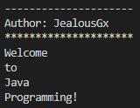

* What will be the result of [System.out.println("\"in quotes\"");]

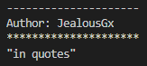

|  |
| --- |
| Exercise 1.1: |
| import java.util.Scanner;  public class ComputePKR {  public static void main(String[] args) {  System.out.println("---------------------");  System.out.println("Author: JealousGx");  System.out.println("*********************");  Scanner input = new Scanner(System.in);  System.out.print("Enter decimal number: ");  double amount = input.nextDouble();  int remainingAmount = (int)(amount * 100);  ////Number of one lacs  int numOfOneLacs = remainingAmount / 10000000;  remainingAmount %= 10000000;  ///Number of thousands in remainingAmount  int numOfThousands = remainingAmount / 100000;  remainingAmount %= 100000;  int numOfHundreds = remainingAmount / 10000;  remainingAmount %= 10000;  ///Number of tens in remainingAmount  int numOfTens = remainingAmount / 1000;  remainingAmount %= 1000;  ///Number of paisas in remainingAmount  int numOfPaisas = remainingAmount;  System.out.println("Your amount " + amount + " consists of: ");  System.out.println("- " + numOfOneLacs + " lacs!");  System.out.println("- " + numOfThousands + " thousands!");  System.out.println("- " + numOfHundreds + " hundreds!");  System.out.println("- " + numOfTens + " tens!");  System.out.println("- " + numOfPaisas + " paisas!");  System.out.println("---------------------");}} |
| Output: |

|  |
| --- |
| Exercise 1.2: |
| import java.util.Scanner;  public class SumOfDigits {  public static void main(String[] args) {  System.out.println("---------------------");  System.out.println("Author: JealousGx");  System.out.println("*********************");  Scanner input = new Scanner(System.in);  System.out.print("Enter any integer between 1-1000: ");  int num = input.nextInt();  int num1 = num % 10;  num /= 10;  int num2 = num % 10;  num /= 10;  int num3 = num % 10;  num /= 10;  int sum = num1 + num2 + num3;  System.out.println("The sum of " + num3 + ", " + num2 + " & " + num1 + " is: " + sum + ".");  }  } |
| Output: |

|  |
| --- |
| Exercise 1.3: |
| ///Program to display current Pakistan Standard Time  public class CurrentPST {  public static void main(String[] args) {  System.out.println("---------------------");  System.out.println("Author: JealousGx");  System.out.println("*********************");  ////Total milliseconds since 1970 GMT  long totalMilliSecs = System.currentTimeMillis();  ////Total seconds since 1970  long totalSeconds = totalMilliSecs / 1000;  ///Current seconds  long currentSecs = totalSeconds % 60;  ////Total minutes  long totalMins = totalSeconds / 60;  ////Current minutes  long currentMins = totalMins % 60;  ///Total hours  long totalHours = totalMins / 60;  ////Current hours  long currentHours = (totalHours % 24) + 5;  ///Printing the current time  System.out.println("Current time: " + currentHours + ":" + currentMins + ":" + currentSecs + " GMT");  }  } |
| Output: |

|  |
| --- |
| Exercise 1.4: |
| import java.util.Scanner;  public class ComputeBMI {  public static void main(String[] args) {  System.out.println("---------------------");  System.out.println("Author: JealousGx");  System.out.println("*********************");  Scanner input = new Scanner(System.in);  ///Taking user weight in lbs  System.out.print("Enter your weight in pounds: ");  double userWeightInLB = input.nextDouble();  ///Taking user height in inches  System.out.print("Enter your height in inches: ");  double userHeightInIn = input.nextDouble();  ///Converting height and weight into meters and kgs respectively.  double userWeight = userWeightInLB * 0.45359237;  double userHeight = userHeightInIn * 0.0254;  ///Calculating BMI  double userBMI = (userWeight) / (userHeight * userHeight);  System.out.println("Your BMI is: " + userBMI);  System.out.println("---------------------");  }  } |
| Output: |

|  |
| --- |
| Exercise 1.5: |
| import java.util.Scanner;  public class ComputeDistance {  public static void main(String[] args) {  System.out.println("---------------------");  System.out.println("Author: JealousGx");  System.out.println("*********************");  Scanner input = new Scanner(System.in);  System.out.print("Enter the value of x1: ");  double x1 = input.nextDouble();  System.out.print("Enter the value of x2: ");  double x2 = input.nextDouble();  System.out.print("Enter the value of y1: ");  double y1 = input.nextDouble();  System.out.print("Enter the value of y2: ");  double y2 = input.nextDouble();  ////Computing the distance separately.  double x = x2 - x1;  double y = y2 - y1;  double internalSum = (x * x) + (y * y);  ////Computing the distance  double pointDistance = Math.pow(internalSum, 0.5);  System.out.println("The distance from (" + x1 + ", " + y1 + ") & (" + x2 + ", " + y2 + ") is: " + pointDistance);  System.out.println("---------------------");  }  } |
| Output: |

|  |
| --- |
| Exercise 1.6: |
| import java.util.Scanner;  public class Table {  public static void main(String[] args) {  System.out.println("---------------------");  System.out.println("Author: JealousGx");  System.out.println("*********************");  Scanner input = new Scanner(System.in);  System.out.print("Enter the number for table: ");  int tableNum = input.nextInt();  System.out.println(1 + " * " + tableNum + " = " + tableNum * 1);  System.out.println(2 + " * " + tableNum + " = " + tableNum * 2);  System.out.println(3 + " * " + tableNum + " = " + tableNum * 3);  System.out.println(4 + " * " + tableNum + " = " + tableNum * 4);  System.out.println(5 + " * " + tableNum + " = " + tableNum * 5);  System.out.println(6 + " * " + tableNum + " = " + tableNum * 6);  System.out.println(7 + " * " + tableNum + " = " + tableNum * 7);  System.out.println(8 + " * " + tableNum + " = " + tableNum * 8);  System.out.println(9 + " * " + tableNum + " = " + tableNum * 9);  System.out.println(10 + " * " + tableNum + " = " + tableNum * 10);  }  } |
| Output: |

|  |
| --- |
| Exercise 1.7: |
| import java.util.*;  public class CostOfDriving {  public static void main(String[] args) {  System.out.println("---------------------");  System.out.println("Author: JealousGx");  System.out.println("*********************");  Scanner input = new Scanner(System.in);  ///Taking inputs  System.out.print("Enter the distance (In miles): ");  double distance = input.nextDouble();  System.out.print("Enter fuel efficiency (In miles per gallon): ");  double milesPerGallon = input.nextDouble();  System.out.print("Enter the price per gallon: ");  double pricePerGallon = input.nextDouble();  ///Calculating the cost of the trip.  double costOfTrip = (distance / milesPerGallon) * pricePerGallon;  System.out.println("\nThe cost of the trip is $" + costOfTrip + "...");  System.out.println("---------------------");  }  } |
| Output: |

* From command prompt: command [notepad] and [write] are used to open Notepad and WordPad, respectively.

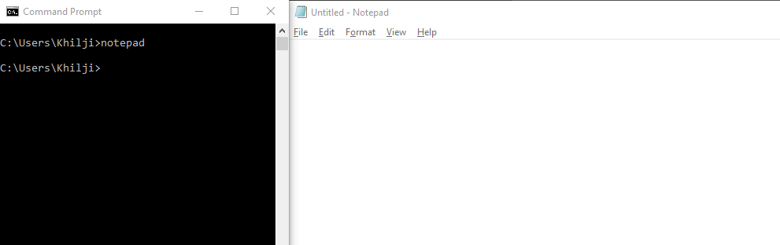

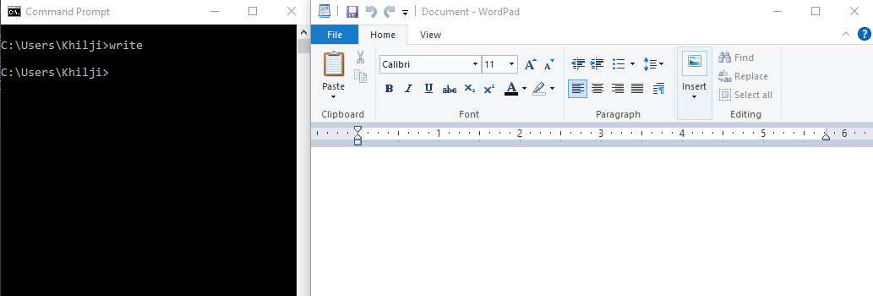

* [notepad filename.java] can be used to directly open program in Notepad using command window.
* If such file does not exist, then you will be prompted to create notepad file with name filename.java

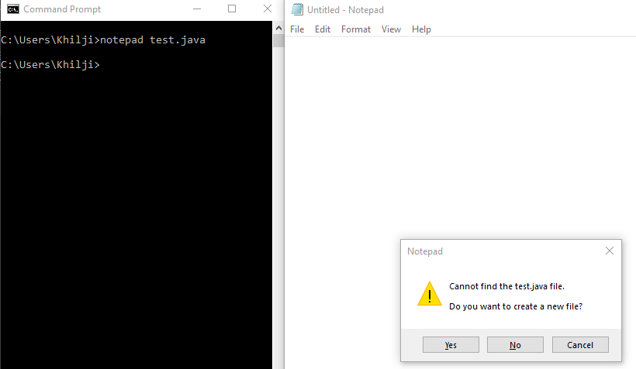

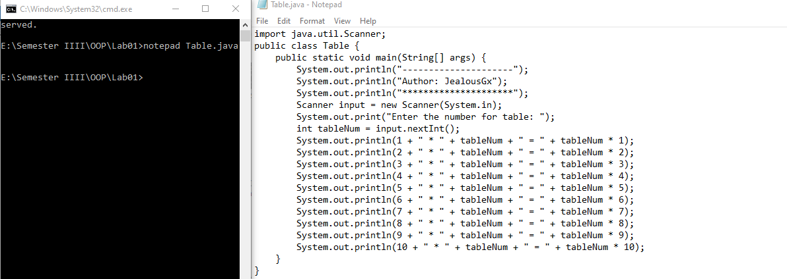

* A program written in notepad can be opened in Wordpad using [write filename.java] command in command prompt.

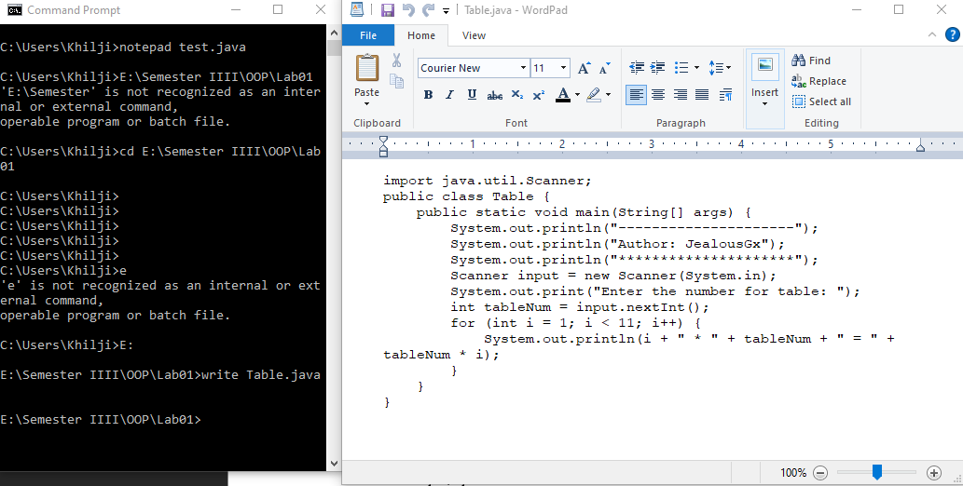

* [type filename.java] opens file contents in command prompt.

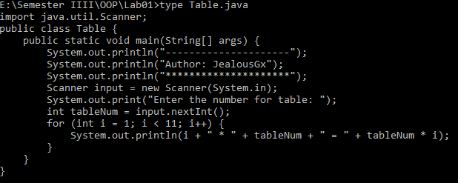

* What is the use of [set classpath=class_path_here]? i.e. set classpath=c:\code\aziz\

The command sets the path for class where the compiler creates .class file. It can be set temporarily or permanently.

* How can we run Java programs using command prompt and without navigating to actual directory where [filename.java] is stored?

We can run Java programs using “Jshell” command in the command prompt without navigating to the file folder.